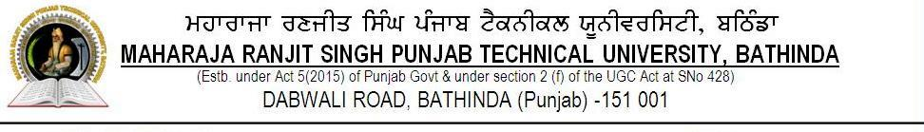
(Progress Report of PhD Candidates admitted with MRSPTU)
PART A (To be filled in by the PhD candidate enrolled)

Ph.D. PROGRESS REPORT
Name of the candidate
Faculty & Department
Date of registration & Registration No.
Date of enrolment & Enrolment No.
Name of Supervisor & Co-supervisor
Tentative title of PhD thesis work
COURSE WORK completed (Y/N)
If Yes, course work credits earned
Performance review period / Semester | FROM _______ TO ___________
MENTION IN MAXIMUM 250 WORDS THE SUMMARY /POGRESS OF YOUR WORK DURING THE ABOVE PERIOD:
R. PUBLICATIONS (Publications must bear the MRSPTU affiliations on them for consideration by the university/Attach first page)

Any other related activity carried out to supplement your research work:

(Any other special comment to be communicated to MRSPTU in regards to Supervisor/Co-supervisor (else fill NIL) : _______ )

(Signature of the Student with Date)
(PART B) (To be filled in by the Supervisor)
Performance of the PhD candidate ______________ was ________________________ during______________

Academic or any other special comment to be communicated to MRSPTU about the candidate (else fill Nil): _________

(Date and Signature of Supervisor(s))

(One copy be retained in candidate’s file in the Department and another be forwarded to o/o Dean R&D, MRSPTU, by concerned HoD)

PART C: (To be filled in by the DDRC members after examining PhD progress Report /open Seminar Presentation)

The candidate ______________________ Regd No:_____________________________ in the Faculty _________ Discipline ___________ appeared on _______________________at __________________________________(place) and presented her/his PhD progress report / seminar before the DDRC on the PhD Thesis work done From ________________To ____________________.

- Quality of work done: Excellent / Good / Satisfactory / Unsatisfactory : _____________________________
(Please give additional comments if progress is unsatisfactory) _____________________________________
- Quantity of work done( Enough / Just Sufficient / Insufficient)_____________________________
- Progress Seminar should be given again after ______________________ months.
(This option may be used if progress is unsatisfactory and/or insufficient.)

Name: | ( Prof. _________________________________ ) |  | ( Prof. ____________________________________ )
 |  | Chairperson DDRC |  |  |  | Supervisor
Name: | ( Prof. _________________________________ ) |  | ( Prof. ____________________________________ )
 |  | Member DDRC |  |  |  | Member DDRC
Name: | ( Prof. _________________________________ ) |  | ( Prof. ____________________________________ )
 |  | Member DDRC |  |  |  | Member DDRC

To be forwarded to the O/O Dean(R&D), MRSPTU by HoD/PhD Coordinator/convener DDRC
(A copy to be retained in the student’s file in the concerned Deptt. and got noted from concerned candidate)

Remarks, if any: _______________________________________

(Signature with date & Stamp)

